ICEngineSoft Test Report

Report Date : Wed, Dec 14, 2022 , Time : 12:43:13 AM
Organization : Organisation, Operator : Operator
Data File : 13-12 Diesel.xlsx, Last Modified Date: Wed, Dec 14, 2022,
Config. File : Kirloskar TV1 Engine.xls

Engine Details :

ICEngine set up under test is Kirloskar TV1 having power 5.20 kW @ 1500 rpm which is 1 Cylinder, Four stroke , Constant Speed, Water Cooled, Diesel Engine, with Cylinder Bore 87.50(mm), Stroke Length 110.00(mm), Connecting Rod length 234.00(mm), Compression Ratio 17.50, Swept volume 661.45 (cc)

Combustion Parameters :

Specific Gas Const (kJ/kgK) : 1.00, Air Density (kg/m^3) : 1.17, Adiabatic Index : 1.41, Polytrophic Index : 1.10, Number Of Cycles : 10, Cylinder Pressure Referance : 6, Smoothing 2, TDC Reference :-1

Performance Parameters :

Orifice Diameter (mm) : 20.00, Orifice Coeff. Of Discharge : 0.60, Dynamometer Arm Legnth (mm) : 185, Fuel Pipe dia (mm) : 12.40, Ambient Temp. (Deg C) : 27, Pulses Per revolution : 360, Fuel Type : Diesel, Fuel Density (Kg/m^3) : 830, Calorific Value Of Fuel (kj/kg) : 42500

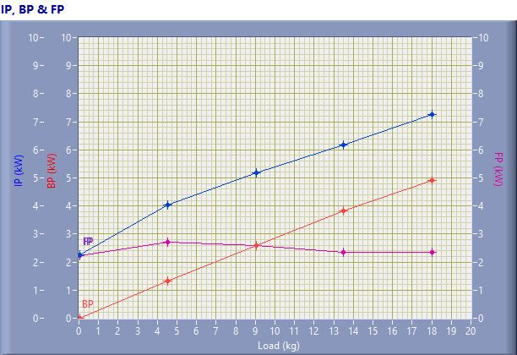

IP, BP & FP

Speed (rpm) | Load (kg) | IP (kW) | BP (kW) | FP (kW)
1547.00 | 0.02 | 2.25 | 0.01 | 2.24
1540.00 | 4.51 | 4.04 | 1.32 | 2.72
1505.00 | 9.05 | 5.18 | 2.59 | 2.59
1491.00 | 13.50 | 6.18 | 3.83 | 2.35
1434.00 | 18.02 | 7.26 | 4.91 | 2.35

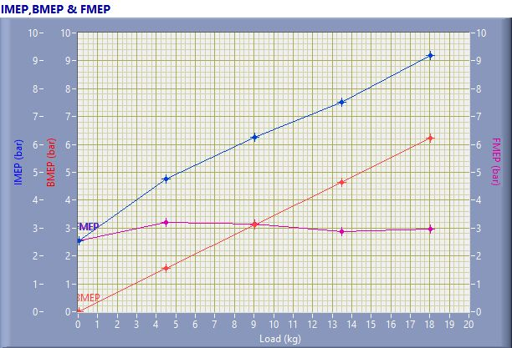

IMEP,BMEP & FMEP

Speed (rpm) | Load (kg) | IMEP (bar) | BMEP (bar) | FMEP (bar)
1547.00 | 0.02 | 2.55 | 0.01 | 2.54
1540.00 | 4.51 | 4.77 | 1.55 | 3.21
1505.00 | 9.05 | 6.27 | 3.12 | 3.15
1491.00 | 13.50 | 7.52 | 4.66 | 2.86
1434.00 | 18.02 | 9.19 | 6.21 | 2.98

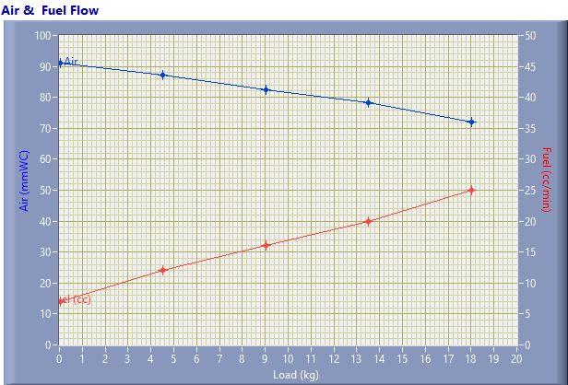

Air & Fuel Flow

Speed (rpm) | Load (kg) | Air (mmWC) | Fuel (cc/min)
1547.00 | 0.02 | 91.05 | 7.00
1540.00 | 4.51 | 87.34 | 12.00
1505.00 | 9.05 | 82.54 | 16.00
1491.00 | 13.50 | 78.25 | 20.00
1434.00 | 18.02 | 72.01 | 25.00

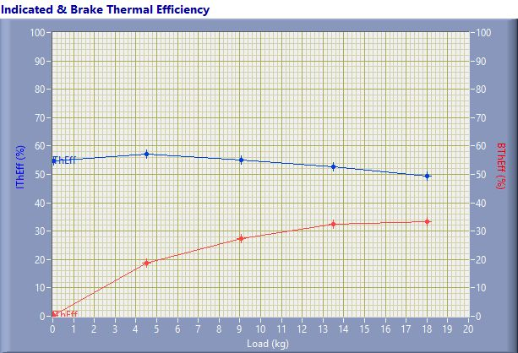

Indicated & Brake Thermal Efficiency

Speed (rpm) | Load (kg) | IThEff (%) | BThEff (%)
1547.00 | 0.02 | 54.64 | 0.16
1540.00 | 4.51 | 57.29 | 18.69
1505.00 | 9.05 | 55.08 | 27.51
1491.00 | 13.50 | 52.54 | 32.54
1434.00 | 18.02 | 49.42 | 33.42

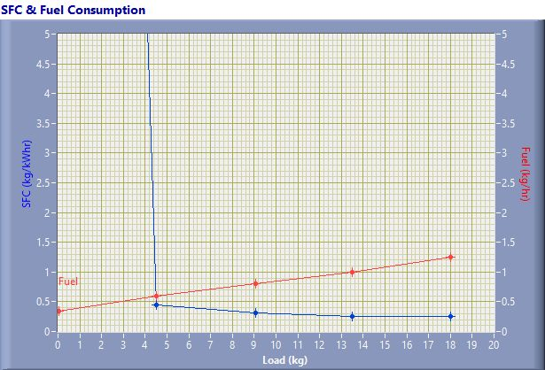

SFC & Fuel Consumption

Speed (rpm) | Load (kg) | SFC (kg/kWh) | Fuel (kg/h)
1547.00 | 0.02 | 51.55 | 0.35
1540.00 | 4.51 | 0.45 | 0.60
1505.00 | 9.05 | 0.31 | 0.80
1491.00 | 13.50 | 0.26 | 1.00
1434.00 | 18.02 | 0.25 | 1.25

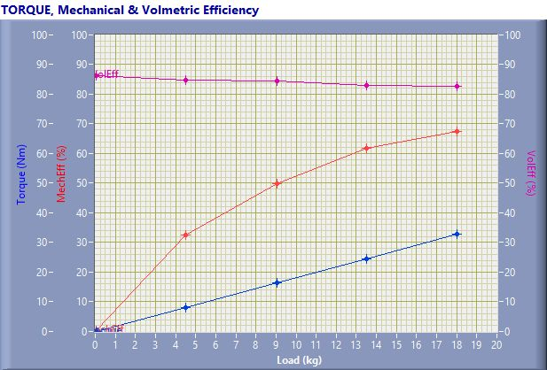

TORQUE, Mechanical & Volmertic Efficiency

Speed (rpm) | Load (Kg) | Torque (Nm) | Mech Eff. (%) | Vol Eff. (%)
1547.00 | 0.02 | 0.04 | 0.30 | 86.23
1540.00 | 4.51 | 8.18 | 32.63 | 84.84
1505.00 | 9.05 | 16.42 | 49.94 | 84.40
1491.00 | 13.50 | 24.51 | 61.94 | 82.95
1434.00 | 18.02 | 32.71 | 67.61 | 82.73

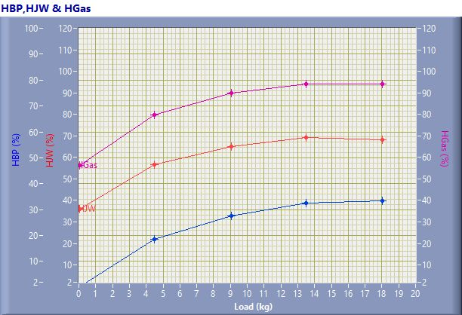

HBP,HJW & HGas

Speed (rpm) | Load (kg) | HBP (%) | HJW (%) | HGas (%) | HRad (%)
1547.00 | 0.02 | 0.16 | 35.76 | 20.30 | 43.77
1540.00 | 4.51 | 18.69 | 38.08 | 23.06 | 20.16
1505.00 | 9.05 | 27.51 | 37.40 | 24.86 | 10.23
1491.00 | 13.50 | 32.54 | 36.55 | 25.09 | 5.82
1434.00 | 18.02 | 33.42 | 34.87 | 25.66 | 6.05

Observation Data

Speed (rpm) | Load (kg) | Comp Ratio | T1 (deg C) | T2 (deg C) | T3 (deg C) | T4 (deg C) | T5 (deg C) | T6 (deg C)
1547 | 0.02 | 17.50 | 33.34 | 41.75 | 33.35 | 33.50 | 114.02 | 93.66
1540 | 4.51 | 17.50 | 33.43 | 48.79 | 33.45 | 37.34 | 198.56 | 152.66
1505 | 9.05 | 17.50 | 33.52 | 53.63 | 33.52 | 40.49 | 257.86 | 196.96
1491 | 13.50 | 17.50 | 33.69 | 58.25 | 33.70 | 45.72 | 323.90 | 246.25
1434 | 18.02 | 17.50 | 33.81 | 63.10 | 33.81 | 50.95 | 418.79 | 307.35

Observation Data

Air (mmWC) | Fuel (cc/min) | WaterFlow Engine (lph) | WaterFlow Cal (lph)
91.05 | 7.00 | 150 | 75
87.34 | 12.00 | 150 | 75
82.54 | 16.00 | 150 | 75
78.25 | 20.00 | 150 | 75
72.01 | 25.00 | 150 | 75

Result Data

Torque (Nm) | BP (kW) | FP (kW) | IP (kW) | BMEP (bar) | IMEP (bar) | BTHE (%) | ITHE (%) | Mech Eff. (%)
0.04 | 0.01 | 2.24 | 2.25 | 0.01 | 2.55 | 0.16 | 54.64 | 0.30
8.18 | 1.32 | 2.72 | 4.04 | 1.55 | 4.77 | 18.69 | 57.29 | 32.63
16.42 | 2.59 | 2.59 | 5.18 | 3.12 | 6.27 | 27.51 | 55.08 | 49.94
24.51 | 3.83 | 2.35 | 6.18 | 4.66 | 7.52 | 32.54 | 52.54 | 61.94
32.71 | 4.91 | 2.35 | 7.26 | 6.21 | 9.19 | 33.42 | 49.42 | 67.61

Result Data

Air Flow (kg/h) | Fuel Flow (kg/h) | SFC (kg/kWh) | Vol Eff. (%) | A/F Ratio | HBP (%) | HJW (%) | HGas (%) | HRad (%)
31.07 | 0.35 | 51.55 | 86.23 | 89.14 | 0.16 | 35.76 | 20.30 | 43.77
30.44 | 0.60 | 0.45 | 84.84 | 50.93 | 18.69 | 38.08 | 23.06 | 20.16
29.59 | 0.80 | 0.31 | 84.40 | 37.13 | 27.51 | 37.40 | 24.86 | 10.23
28.81 | 1.00 | 0.26 | 82.95 | 28.92 | 32.54 | 36.55 | 25.09 | 5.82
27.64 | 1.25 | 0.25 | 82.73 | 22.20 | 33.42 | 34.87 | 25.66 | 6.05

